**Assignment -2**

Python Programming

|  |  |
| --- | --- |
| Assignment Date | 19 September 2022 |
| Student Name | Mr. P.Eswaramoorthy |
| Student Roll Number | 422119104006 |
| Maximum Marks | 2 Marks |

**Question:**

**Build a python code ,Assume you get temperature and humidity values (generated with random function to a variable) and write a condition to continuously detect alarm in case high temperature .**

|  |
| --- |
| **Solution:** |
|  |
|  | import random  temp=random.randint(1,100)  humidity=random.randint(1,100)  print(temp and humidity);  if ((temp<50)&(humidity<40)):  print("Temperature and Humidity is normal :")    print("Alarm off")  elif((temp<50)&(humidity>40)):  print("Temperature is low")  print("Humidity is high")  print("Alarm off")  elif((temp>50) & (humidity<40)):  print("Temperature is high:")  print("Humidity is normal")  print("Alarm on")    elif((temp>80) & (humidity>80)):  print("Temperature and Humidity is very high")    print("Alarm on") |
|  |  |
|  |  |
|  |  |
|  |  |
|  |  |
|  |  |
|  |  |
|  |  |

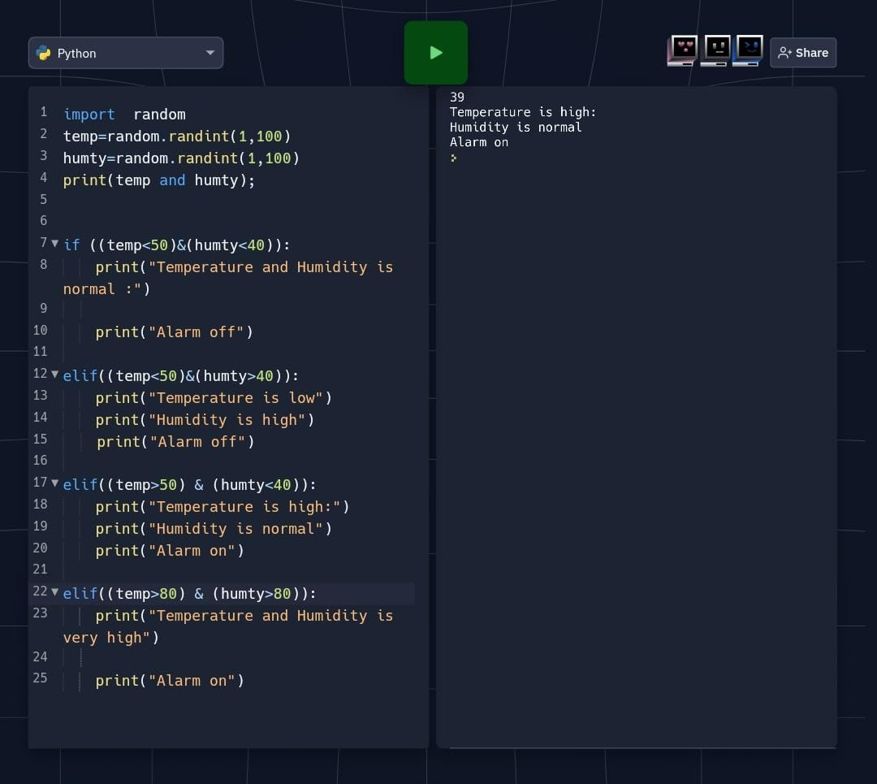Output: